**Wines of Naara Aaba: A Journey into India's First Organic Kiwi Winery**

**Introduction**

Naara Aaba is a distinguished winery based in the scenic **Ziro Valley of Arunachal Pradesh, India**. Founded in **2017** by agricultural engineer **Tage Rita**, it holds the distinction of being **India’s first organic kiwi wine producer**. The winery has gained national and international recognition for its innovative approach to winemaking, promoting **sustainability, community empowerment, and the use of locally grown organic fruits**. This article explores the origins, production process, impact, and growing prominence of Naara Aaba wines in the global market.

**1. The Origin of Naara Aaba**

The story of **Naara Aaba** is deeply rooted in the vision of **Tage Rita**, a woman entrepreneur who sought to transform Arunachal Pradesh's abundant yet underutilized kiwi fruit into a premium wine. **Ziro Valley**, home to the **Apatani tribe**, is known for its pristine landscapes and vast agricultural potential. Despite producing high-quality **kiwis, apples, plums, and pears**, farmers in the region struggled due to a lack of adequate market access.

Rita identified an opportunity to create value-added products using surplus kiwi fruit and embarked on the ambitious journey of **establishing India's first organic kiwi wine brand**. The brand name "Naara Aaba" is a tribute to **her late father-in-law**, reflecting deep-rooted family values and traditions. Today, the winery stands as a symbol of **entrepreneurial resilience and sustainable agricultural development**.



**2. The Unique Terroir of Ziro Valley**

The quality of any wine is largely influenced by the terroir—the unique combination of **soil, climate, and geography**—where the grapes or fruits are grown.

**a) Soil & Climate**

* Ziro Valley has **fertile alluvial soil** rich in nutrients, making it ideal for growing kiwis and other fruits.
* The **moderate temperatures**, combined with **high altitude (over 5,500 feet above sea level)**, provide the perfect conditions for slow ripening, leading to a **balanced sugar-acid ratio** in the fruit.
* The region receives **ample rainfall** but has well-drained soil, preventing excessive water retention.

**b) Sustainability Practices**

* Naara Aaba focuses on **organic farming methods**, ensuring that no chemical fertilizers or pesticides are used in cultivation.
* Local farmers are encouraged to use **natural composting and eco-friendly pest control techniques**, preserving biodiversity and soil health.
* The winery also emphasizes **low-carbon-footprint production methods** to align with environmentally conscious winemaking practices.

**3. The Winemaking Process at Naara Aaba**

The **winemaking process** at Naara Aaba is a blend of **traditional wisdom and modern technology**, ensuring premium-quality wines. Here’s a step-by-step breakdown:

**a) Harvesting & Selection**

* The kiwis are handpicked during peak ripening season (September–November) to ensure optimal sweetness and acidity.
* Only **the finest, blemish-free fruits** are chosen for fermentation, ensuring a **pure and natural taste**.

**b) Fermentation**

* The harvested kiwis are crushed, and their juice is extracted.
* The juice undergoes **controlled fermentation in stainless steel tanks**, where specially selected yeasts convert sugars into alcohol.
* The fermentation process lasts **several weeks**, during which the wine develops its unique aroma and character.

**c) Aging & Bottling**

* After fermentation, the wine is aged to enhance its **flavor profile, aroma, and clarity**.
* The wines are then **filtered and bottled** with precision to ensure consistency and quality.
* Every bottle undergoes **strict quality control measures** before reaching the market.

**4. Product Range**

While kiwi wine remains Naara Aaba’s signature product, the winery has diversified its portfolio to include **other fruit wines**, each with a distinct taste profile:

* **Kiwi Wine** – A signature product, offering a balanced combination of **sweetness, acidity, and tropical flavors**.
* **Apple Wine** – Crisp and slightly tart, capturing the **essence of Himalayan apples**.
* **Plum Wine** – Rich in **fruity and floral notes**, with a naturally sweet aftertaste.
* **Pear Wine** – Delicate and aromatic, with a smooth mouthfeel.
* **Peach Wine** – A soft, fragrant wine with refreshing **summer flavors**.

Each variety reflects the region’s rich biodiversity and commitment to **organic, chemical-free production**.

**5. Tasting Notes and Customer Reviews**

Each Naara Aaba wine has a distinct flavor profile that appeals to wine lovers:

* **Kiwi Wine**: Bright golden hue with **aromas of citrus and honey**. On the palate, it offers **balanced acidity and tropical fruit flavors**.
* **Apple Wine**: Pale yellow color, **crisp green apple aroma**, and a slightly dry finish.
* **Plum Wine**: Deep ruby-red color, **notes of ripe plums and berries**, with a soft sweetness.
* **Pear Wine**: Light straw color, **delicate floral aromas**, and a smooth, slightly off-dry taste.
* **Peach Wine**: Vibrant, **fruity aroma of summer peaches**, light-bodied with a refreshing taste.

Customers have praised Naara Aaba wines for their **unique flavors, smooth finish, and organic quality**. Wine critics have also commended the winery’s commitment to **sustainable production and innovation**.

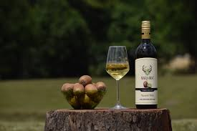

**6. Challenges Faced by Naara Aaba**

Despite its success, Naara Aaba has encountered multiple challenges:

**a) Logistical and Distribution Issues**

* Arunachal Pradesh’s remote location makes **transportation costly and time-consuming**.
* Poor road conditions hinder the efficient distribution of products to major markets in India.

**b) Regulatory Hurdles**

* Indian **excise laws and liquor distribution policies** are complex and vary by state.
* The high taxation on alcoholic beverages makes pricing **less competitive compared to global brands**.

**c) Market Awareness & Consumer Preferences**

* Indian consumers are traditionally **accustomed to grape-based wines**.
* Educating consumers about **fruit wines and their premium quality** remains a marketing challenge.

**7. Global Recognition and Comparisons**

Naara Aaba’s wines have been compared favorably to **European fruit wines**. Experts have highlighted their **natural sweetness, balanced acidity, and rich aroma**, making them an excellent alternative to traditional grape wines.

* Recognized in **international wine expos and sustainability awards**.
* Compared to **New Zealand’s kiwi wines**, Naara Aaba’s offerings have a **distinct terroir-driven character**.
* Interest from **Asian and European importers** suggests a growing market for Indian fruit wines globally.

**8. The Future of Naara Aaba**

The future looks promising for Naara Aaba, with plans for:

* **Expanding Distribution** – Entering larger Indian markets like Delhi, Mumbai, and Bengaluru.
* **International Exports** – Targeting countries with a growing interest in exotic fruit wines.
* **New Wine Variants** – Experimenting with **blueberries, strawberries, and local indigenous fruits**.
* **Eco-friendly Packaging** – Enhancing sustainability with biodegradable packaging solutions.
* **Wine Education Programs** – Increasing awareness about fruit wines through workshops, tastings, and online promotions.
* **Collaboration with Global Wine Experts** – Bringing in expertise to refine winemaking techniques and elevate quality standards.

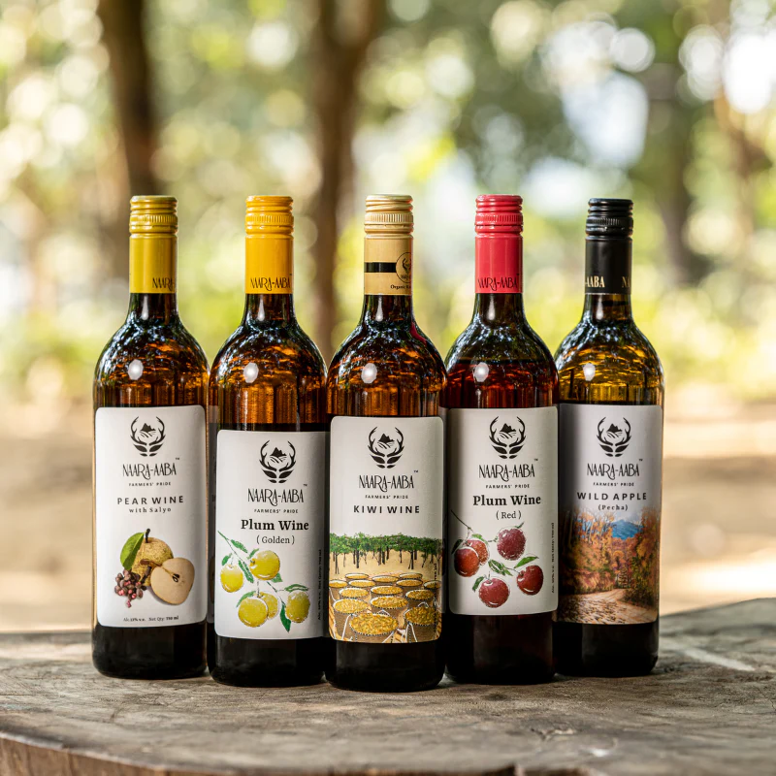

**Conclusion**

Naara Aaba is more than just a winery; it is a **symbol of innovation, sustainability, and economic empowerment** in India’s Northeast. By transforming **organic kiwi farming into a globally recognized winemaking enterprise**, Naara Aaba has placed Ziro Valley on the world map of fine wines. With a commitment to quality, tradition, and environmental consciousness, the future of Naara Aaba shines as bright as its **golden-hued kiwi wine**.